1. Creating and Renaming Files/Directories

# Create a directory named test_dir using mkdir.

mkdir = to make a new directory we use this command.

* Command = mkdir test_dir

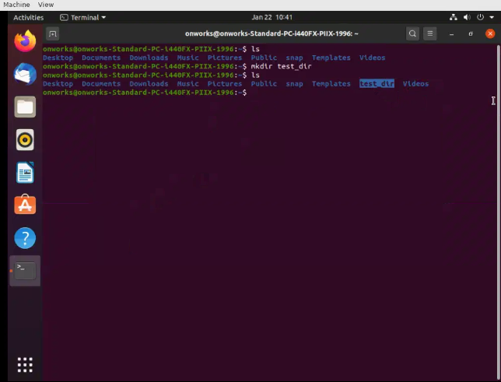

# Inside test_dir, create an empty file called example.txt.

Using touch command we have created new file in test_dir

touch = we use this command for create a new file in directory. We can create .py, .txt , etc.,

* Command = touch testdir/example.txt

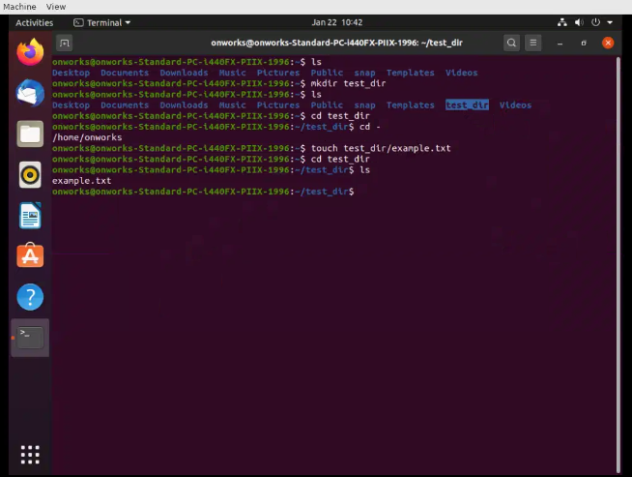

# Rename example.txt to renamed_example.txt using mv

We have renamed the file as renamed_example.txt using mv command

mv = this command is used for move the file so in the below snapshot against the mv we give the path and name in source and target field.

* Command = mv test_dir/example.txt test_dir/renamed_example.txt

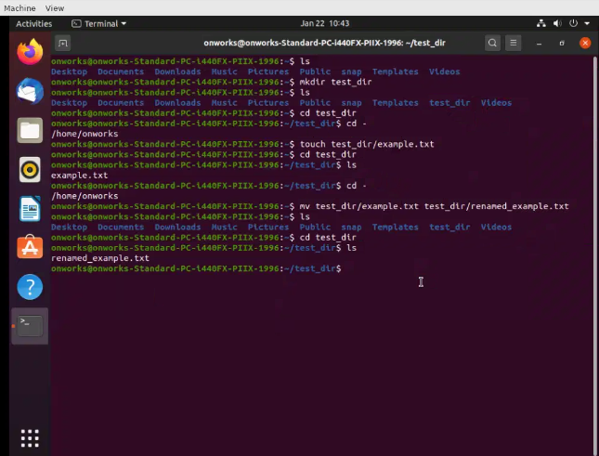

2. Viewing File Contents

Use cat to display the contents of /etc/passwd.

* Command = cat /etc/passwd

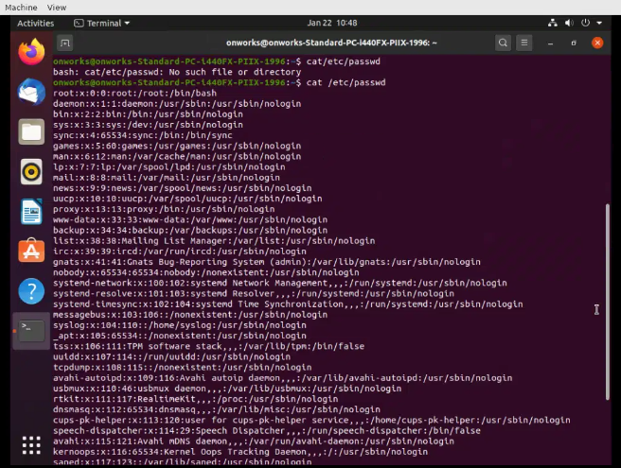

# Display only the first 5 lines of /etc/passwd using head.

Using head command I have fetch first five lines. In the below snapshot I have used the -n 5 for fetch only five rows by default it returning 10 rows

* Command = head -n 5 /etc/passwd

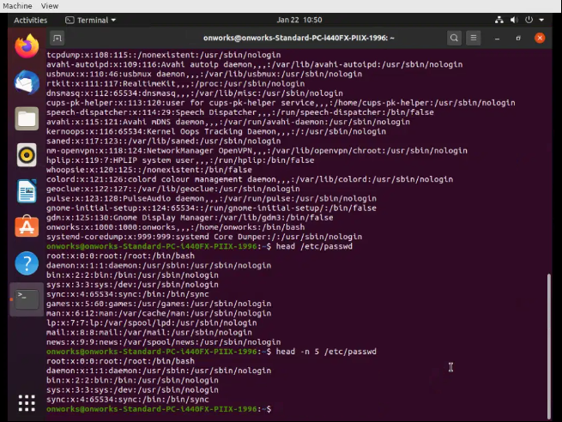

# Display only the last 5 lines of /etc/passwd using tail.

For last 5 lines I have used the **tail** command to get result. In the below snapshot I have used the -n 5 for fetch only five rows by default it returning 10 rows

* Command = tail -n 5 /etc/passwd

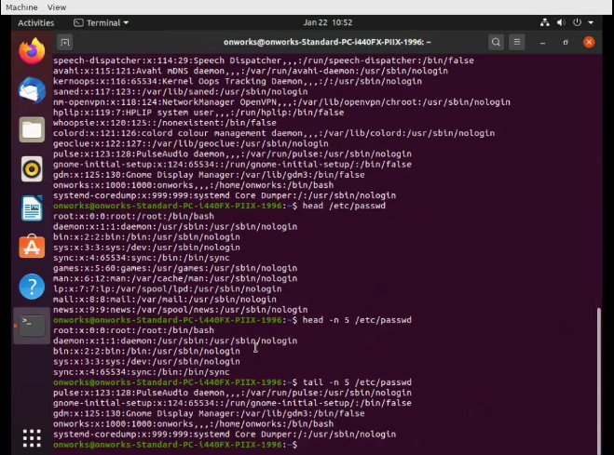

3.Searching for Patterns

#Use grep to find all lines containing the word "root" in /etc/passwd.

To find the word in file we used the grep command.

* Command = grep “root” /etc/passwd

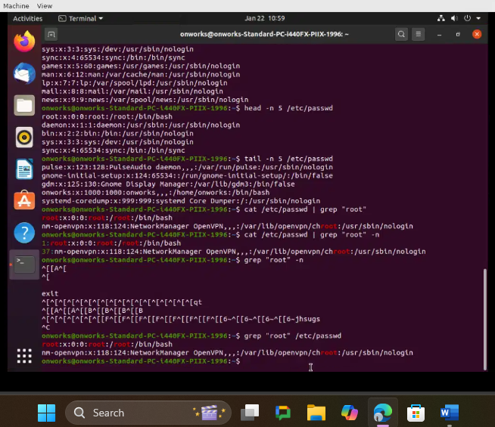

4. Zipping and Unzipping

#Compress the test_dir directory into a file named test_dir.zip using zip.

I have used the zip command for zipped the directory.

-r it is used for to include everything which is in that directory.

* Command = zip -r test_dir.zip test_dir

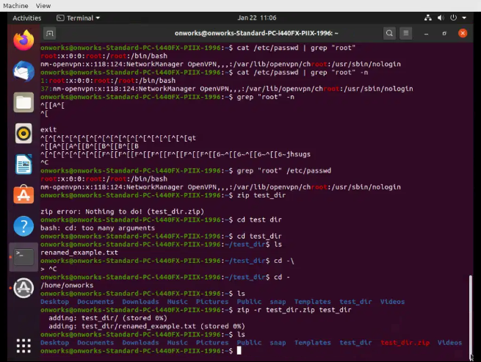

#Unzip test_dir.zip into a new directory named unzipped_dir.

First, I have removed existing directory and then used unzipped commands for unzip it. In below snapshot, using the unzip command its successfully.

* Command = unzip test_dir.zip

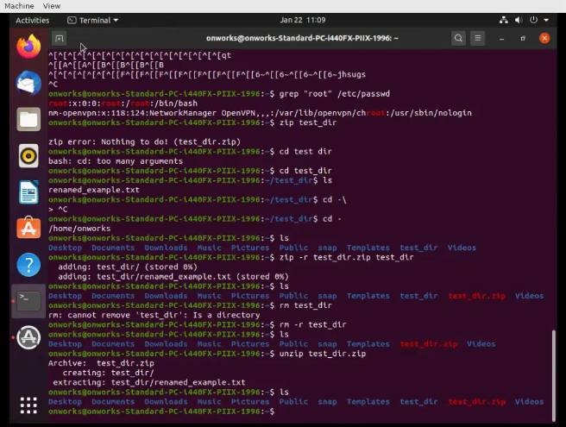

5. Downloading Files

#Use wget to download a file from a URL (e.g., <https://example.com/sample.txt>).

We have download a file using wget command.

* Command = wget <https://example.com/sample.txt>

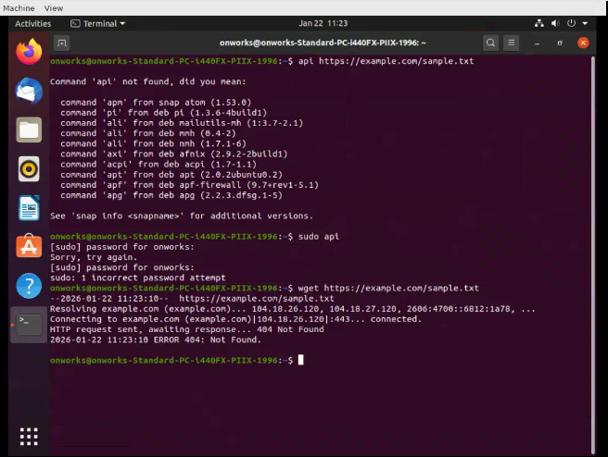

6. Changing Permissions

#Create a file named secure.txt and change its permissions to read-only for everyone using chmod.

I have used the touch command for crate the file. And for set the permission I have used the chmod 444 which is used for only read access permission.

* Command = chmod 444 secure.txt

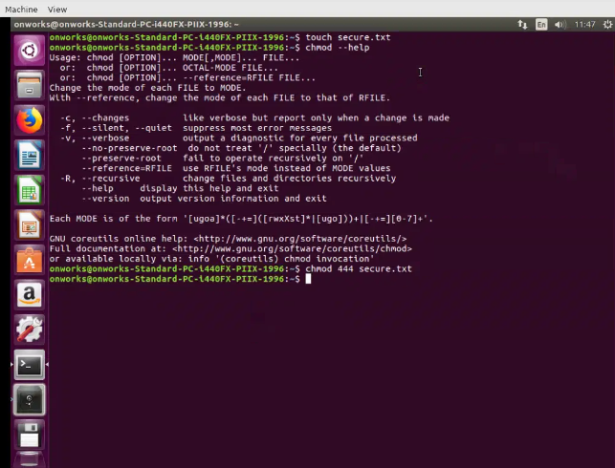

7. Working with Environment Variables

#Use export to set a new environment variable called MY_VAR with the value "Hello, Linux!".

In the below snapshot using the export command I have created new variable as my_  
var. post it to check the variable is created or not I have used the **echo** command.

* Command = export my_var=”Hello Linux!”

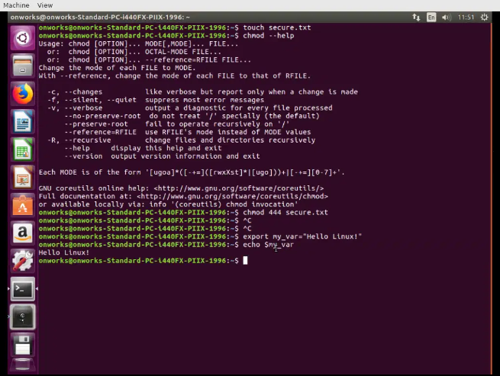

Github-Repo Link => [Linux-Assignment-Tutedude-/README.md at main · MayurGharat141/Linux-Assignment-Tutedude-](https://github.com/MayurGharat141/Linux-Assignment-Tutedude-/blob/main/README.md)